Summary of Analysis

As part of the assignment, I used raw data on standardized testing scores from a city’s schools and created tables using pandas on highest and lowest performing schools, math scores by grade, reading scores by grade, scores by school spending, scores by school size and scores by school type. In the read me file, I have attached my results for convenience. Some of things I noticed was: Highest performing schools were all charter schools, no particular difference among the charter schools when comparing the subset and its percentages. Similarly in lowest performing schools the only significant note is that they were all district schools. Math Scores by grade shows no significant difference between the grades. Reading scores by grade does not show any significant difference between the different grades as well. Scores by school spending shows that lowest spending budget achieved higher scores. Scores by school size doesn’t show any particular difference based on size.

Comparisons:



* Surprisingly according to the scores by school spending analysis, the average lowest budget per student(0-585$) seemed to have a higher passing rate compared to where the average budger per student was higher. 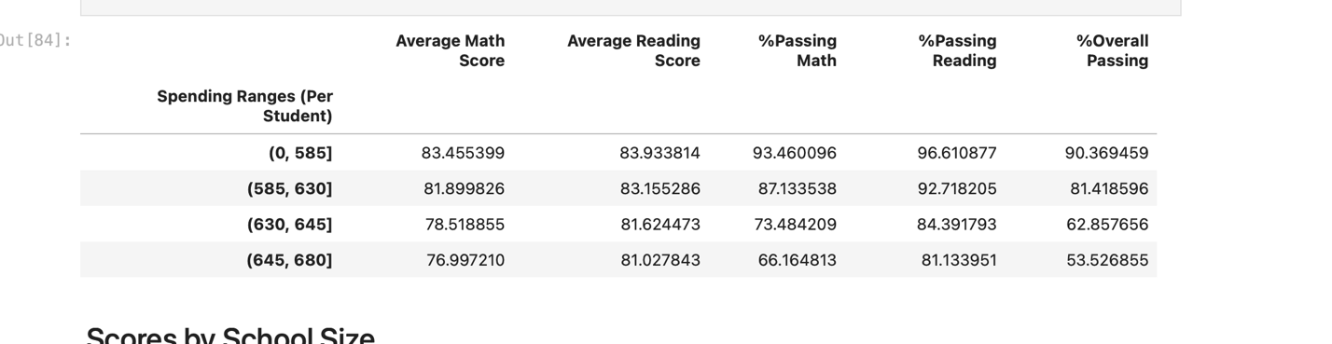
* Students from charter schools comparatively had higher math and reading scores compared to district schools
* 